Issue No: 618/21

Topic: Test conversion Daylimit (Z_MKO_DAYLIMIT_CORRECTION)
Priority: High

System: S02/100

User: IT_ALL_07

Object Type: Paymentterms Details

Change Request Type: ICL1S02

First of all, a note:
Since the Daylimit with and without a leading zero is always updated in the backend without a leading zero. You don't know which Status is current in the backend system. If we now use the correction report to always convert the Daylimit without leading zero to the Daylimit with leading zero. It happens that we overwrite the Daylimit values in the MDG and we have different values in the MDG and in the backed.
You should modify the report so that you check which timestamp is more current and accept the more current content and set the other older data set to Inactive.

Test-Step 1:
Create a PT with Daylimit=6 and two attachments (Fig.1)

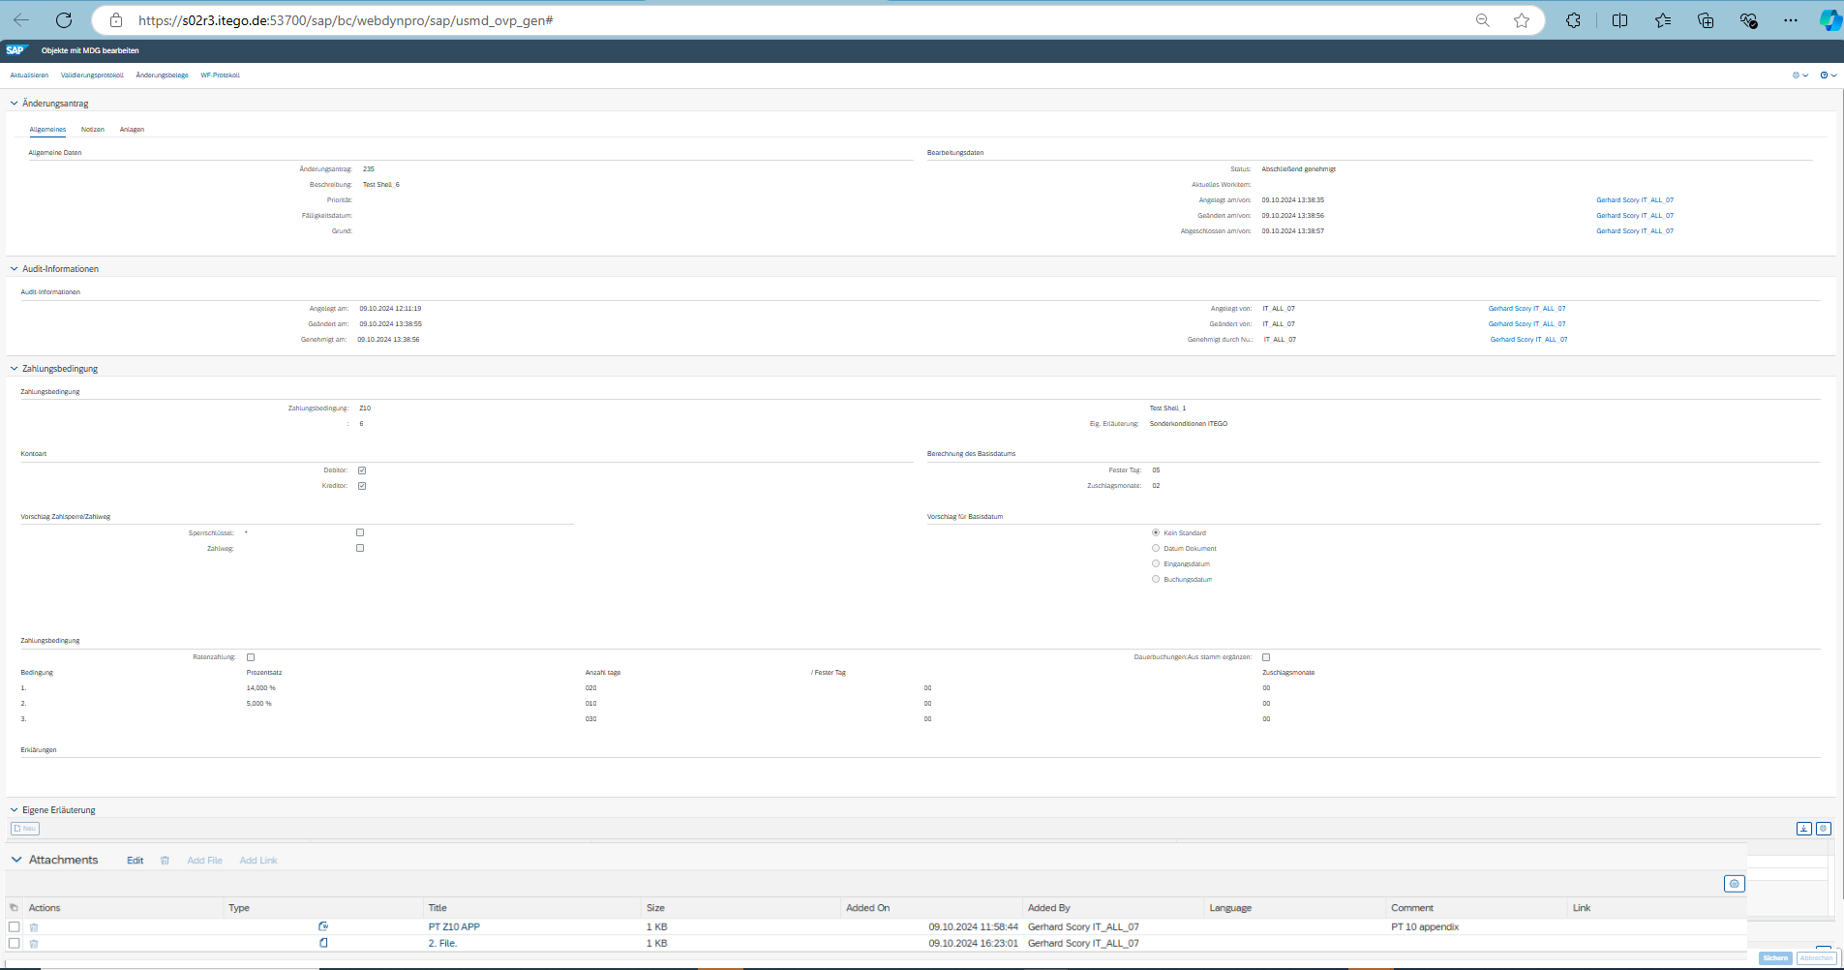
Fig. 1

Step2:
Create a PT with Daylimit=06 and one attachment (Fig. 2)

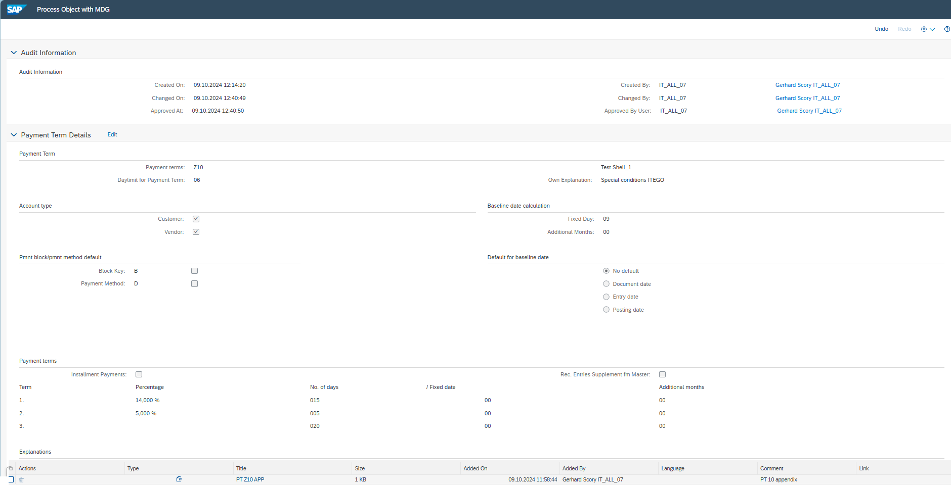
Fig. 2

Test-Step 3:
Correction run with Z_MKO_DAYLIMIT_CORRECTION.
The payment term with Daylimit 6 is moved to 06. (Fig. 3)
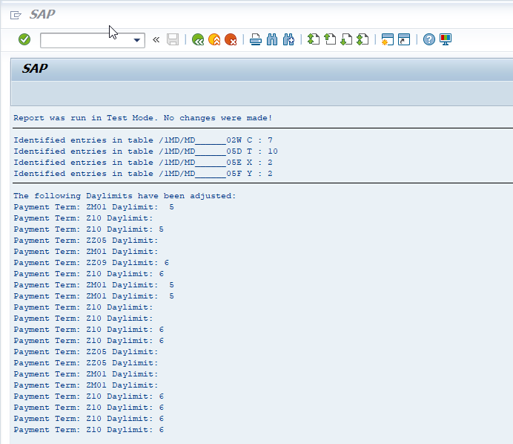
Fig. 3

Test-Step 4:
The result of the run in the UI shows that only payment term 06 is still available with the contents of payment term 6, i.e. payment term 06 has been overwritten (Fig. 4)
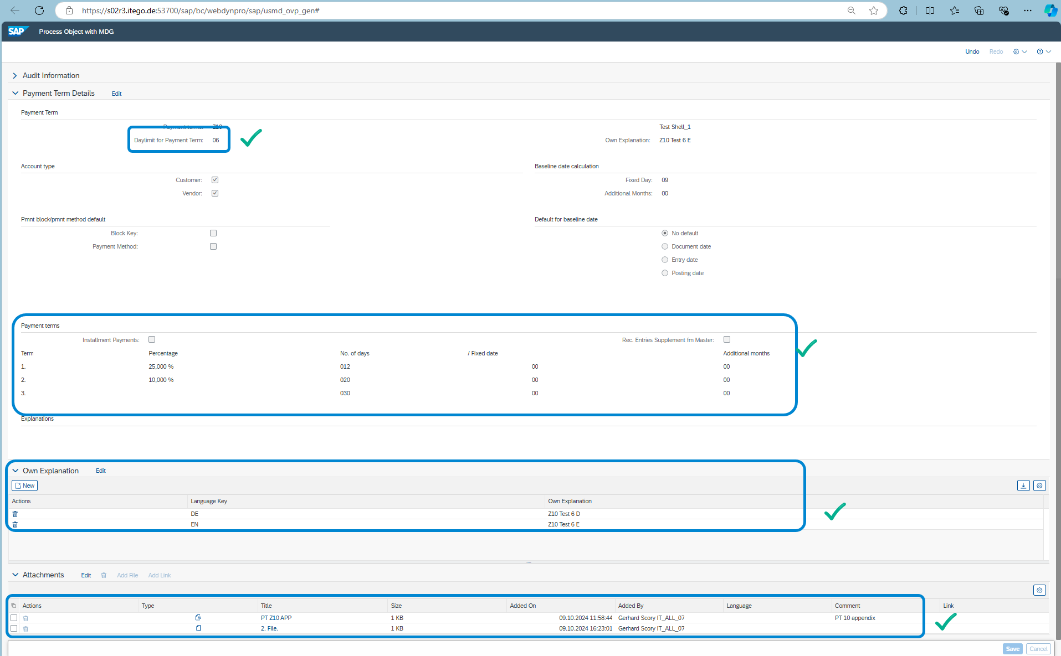
Fig. 4

Test-Step 5:
The generated MDG_Tables were also checked.
With the 4 tables, you can see that the tables before and after (after the correction run) that the table contents of Daylimt=06 were overwritten by the contents of Daylimit=6 (Fig. 5-8).

Test result:
The tables /1MD/MD______02W, /1MD/MD______05D and /1MD/MD______05E are transferred correctly. I.e. the value Daylimit=6 replaces Daylimit=06

Result/Error:
- An error occurs in the MDG table /1MD/MD______05F. The daylimit=6 was not fully implemented here (Fig.8).
- The value Daylimit=ZM01/5 was not converted by the correction program. I guess that the Paymentterm value was created before the data model adjustment, when alphanumeric values could still be entered as Daylimit. (Fig.9,10)
- Another point is that the logging (change documents) is not transferred. For example, if there is a day limit ZM01/5 and a ZM01/05, the change documents is not transferred from ZM01/5 during the correction run ZM01/5 -> ZM01/05. After the correction run, only the data record ZM01/05 remains with the logging of the original overwritten data record ZM01/05 (Fig.11). In this case, the CRs in the change document no longer correspond to the converted payment term.

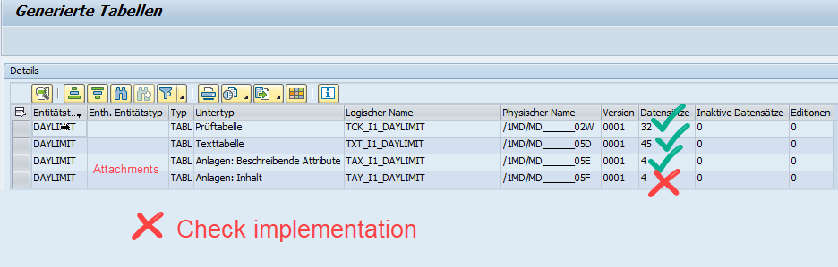
Fig. 5

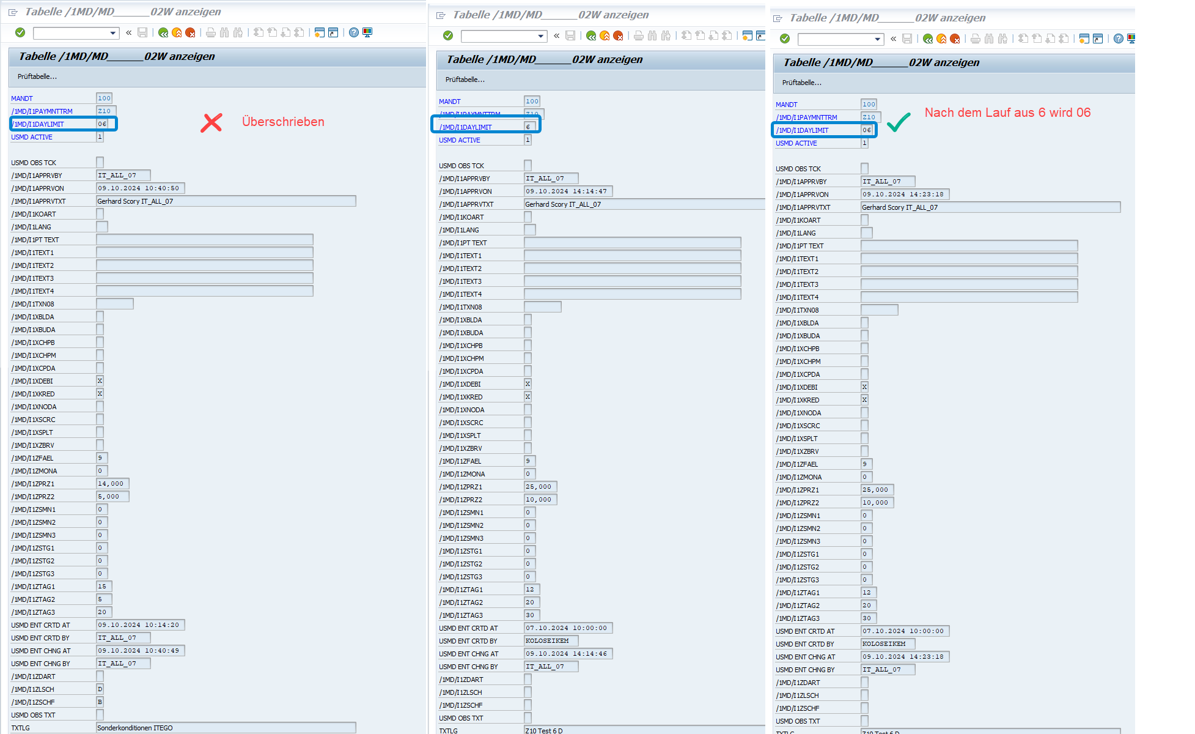
Fig. 6

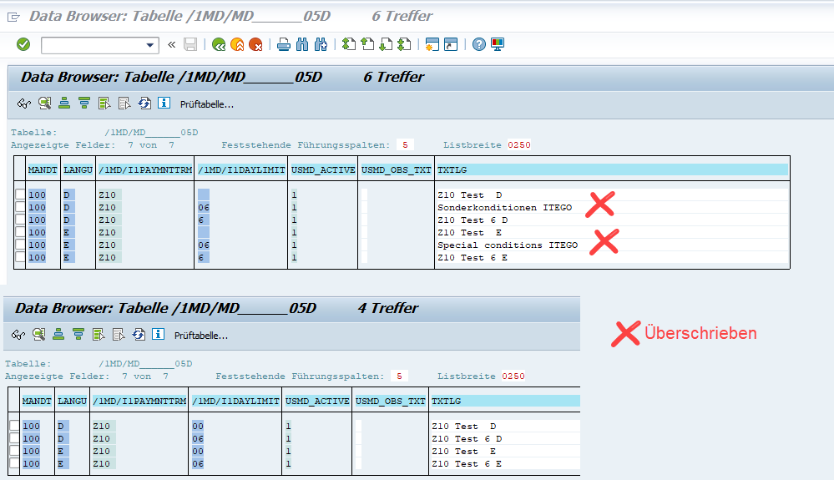
Fig. 7
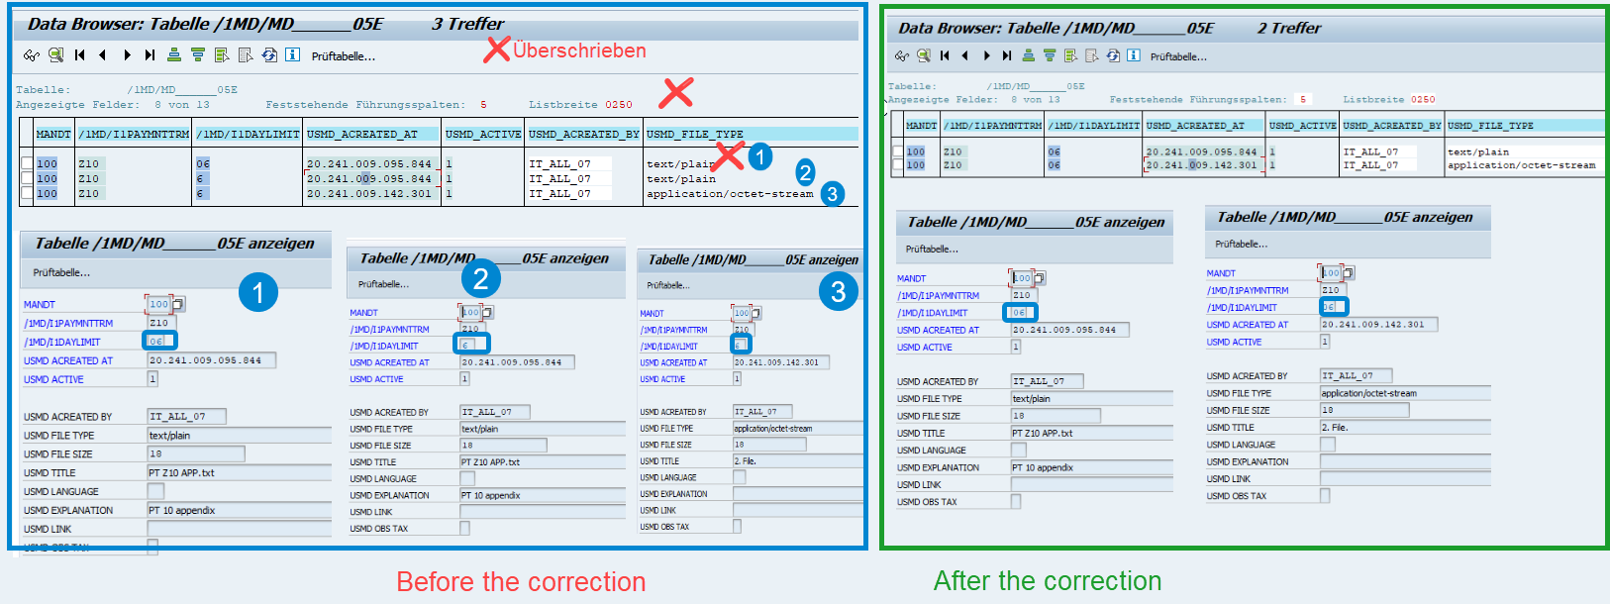

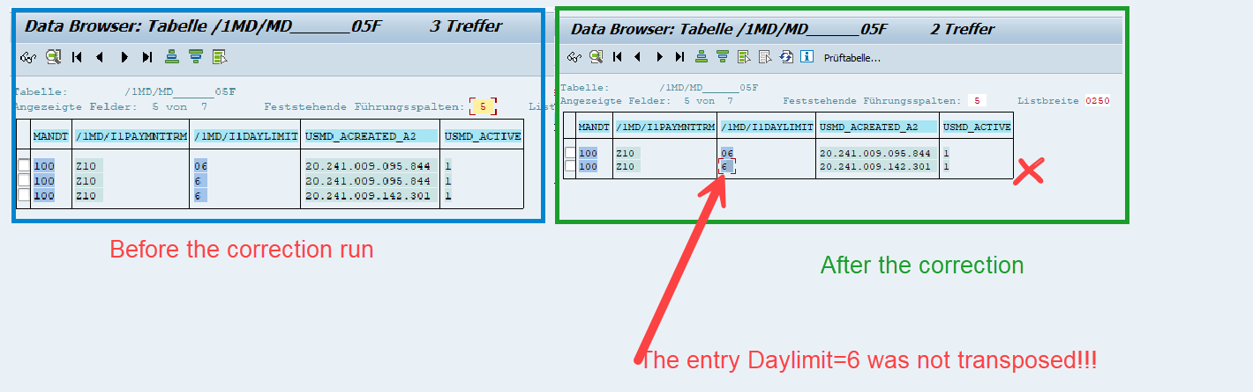
Fig. 8
The value Daylimit=ZM1/5 was not converted by the correction program.

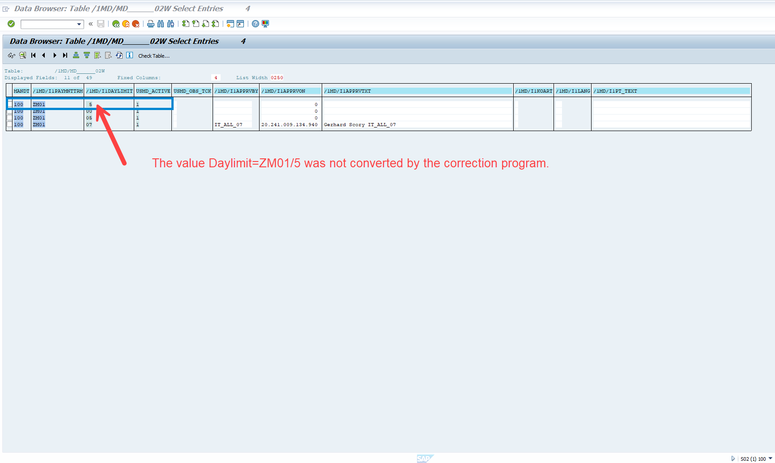
Fig. 9

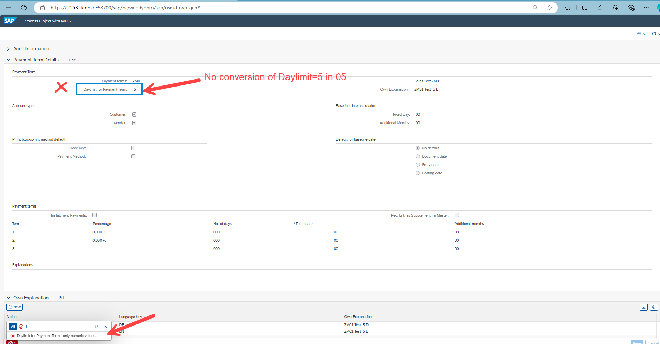
Fig. 10

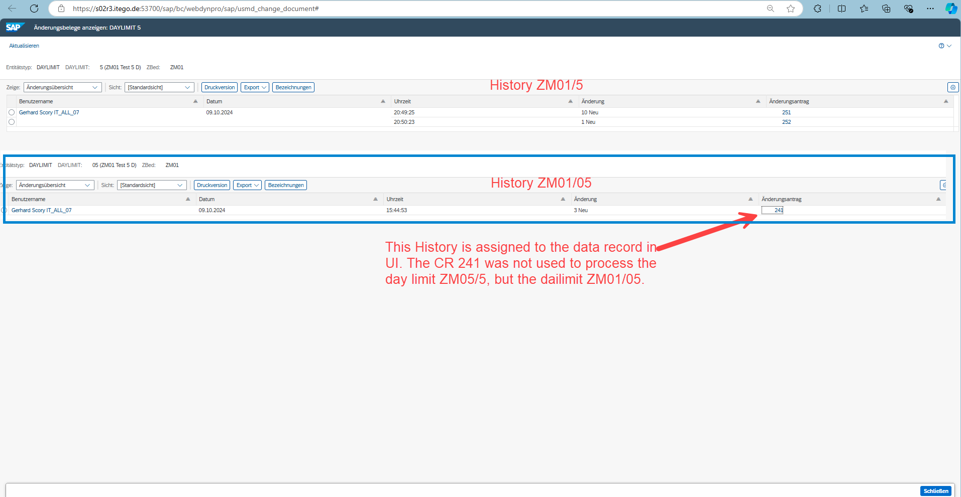
Fig.11

